**KEY AREA 3: TRANSFORMING TEACHING LEARNING PROCESS**

**UNIT: CREATIVE AND JOYFUL LEARNING**

**MODULE NAME: Creating joyful environment for learning**

**About the module**

The heart and minds of children and young adults are wide open to the wonders of learning and the fascinating complexities of life. The school has to provide for all these experiences. However, these experiences of “going to school” destroy children’s spirit to learn, their sense of wonder, their curiosity about the world, and their willingness to care for the human condition.

After finding an ‘extraordinary sameness’ in our schools, Goodlad (1984) wrote “Boredom is a disease of epidemic proportions. Why our schools are not place of joy?” (p 242). As educators, we have the responsibility to educate and inspire the whole child- mind, heart and soul and put more joy into student’s experience of going to school and get more joy out of working inside one. It is rightly said that joyful learning can flourish in school- if you give joy a chance.

As teachers, we always wanted to create joy in the classroom as it facilitates more learning and certainly fast learning. The challenge is:

* How do we create joyful learning in the classroom?
* How do we infect our students with enthusiasm?
* How do we bring fun and joy in the classroom?

What happens inside a classroom has a deep and lasting effect on the mindset that children develop towards lifelong learning. A teacher affects eternity and one can never tell when his influence stops.

**Title**

Creative and Joyful Environment for Teaching Learning

**Learning Objectives**

After going through the module, the learner will be able to

* Create interest among the learners towards learning
* Involve them for more participation
* Create such situation for independent expression
* Pay special attention to the learning materials used in classrooms
* Bring out their innate potentials in learning

**Keywords**

Creativity, Joyful and Experiential Learning, Involvement, Expression, Independence

**Introduction**

Here are some specific ways we can put research into practice and promote joyful learning opportunities. Revamp your classroom to appeal to your students. Creating an inviting classroom where students feel happy and comfortable will help in lowering feelings of stress and increase positive attitudes about learning (<http://www.kidsdiscover.com>). This could be felt among the students of Lum Primary School where we could see the joy in their eyes with each and every task they are assigned to do or are involved in. This was possible because teachers themselves were enjoying doing the activity with interest and enthusiasm. Anybody who is engaged in the task of teaching should understand that “If a child can’t learn the way I teach, maybe we should teach the way they learn.” This is what joyful learning is all about.

**Core Content**

Experiential learning is a well known model in education. It is an immersive, participant focused active approach to learning that engages learners. It is effectively used in schools and other areas of educational leaning. This concept of experiential learning was first explored by John Dewey, Kurt Hahn, Kurt Lewin and Jean Piaget, among others: it was made popular by David A Kolb.

It combines direct experience with focused reflection and requires active involvement in meaning construction. Also encourages collaboration and exchange of ideas and perspectives. It can be course focused or in-class, community focused or work focused. The basic model of experiential leaning cycle is “do reflect decide” Kolb’s defines experiential learning as “the process whereby knowledge is created through the transformation of experience. Knowledge results from combination of grasping and transforming experience.”

If we want students to be charged with enthusiasm, if we want them to see school and learning as joyful, we need to rethink how and what we teach. Let them enjoy learning as they enjoy games. Try to find ways to increase laughter in the classroom.

Joy captures the thrill of true meaning- the curiosity, the passion, the collaboration, the connection, the effort, the fun, the pride, the sharing. Joyful learning speaks to both the learning process, where there is considerable evidence that a focus on techniques that we would describe as joyful is far more effectiveand to an outcome that we believe should be valued highly: joy. This means, engaging empowering and playful learning of meaningful content in a loving and supportive community. Through the joyful learning process a student is always improving knowledge of self and the world. We recognize, however, that joy is experienced individually and that context matters a great deal. We also recognize that experts in the field might use slightly different descriptors. For example, Manoj might describe it as “passion, play and purpose” while Krishna might focus on meaningful engagement”. What is more important to us is that we are having the conversation that we value joy in the learning process and as a life outcome.

Examples are:

1. An organized Tug of War at Majitar Secondary School (<http://youtu.be/eewl_htNttw>) between the two houses as a house competition as well as joyful learning. Other activities like hanger balance, concept of big and small, tapara (leaf plate) making by group of students along with the teacher, colouring activity by LKG students of Majhitar SS has been included.

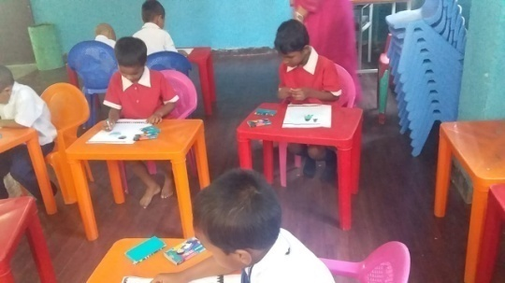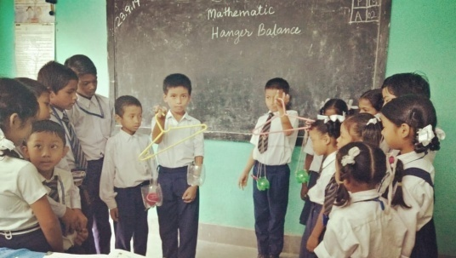

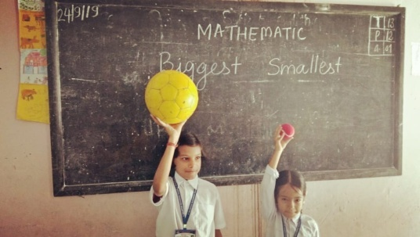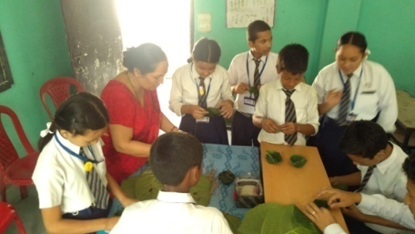

2. A classroom transaction is being done by Mr. Mingma Sherpa with smaller children at Lum Primary School (<https://youtu.be/a3ExNrMCiCw>) with low cost materials on a joyful manner. Concept of mathematics on long and short, tall and short, big and small, LCM utilizing number chart, fun with numbers, play with toys, repetition practice, messaging a CWSN child and experiencing by learners which is improving his bodily postures is a part of joyful learning.

3. Concept of inside and outside, one by one, one by two, one by four, and continued till one by eight while transacting the lesson.

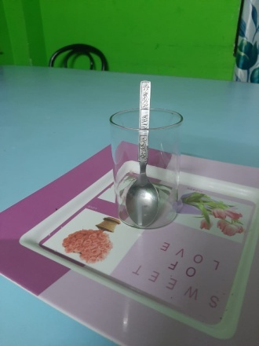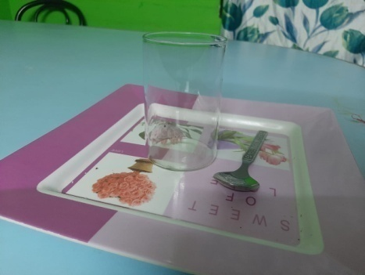

**Teaching the concept of In & Out using objects of daily use**

4. The concept of waste management by the children as a part of joyful learning and the art of making paper caps from single piece of paper of Lingchom Secondary School Students (<https://youtu.be/hYG8_3CAEnA>) in West Sikkim. Langang Secondary School <https://youtu.be/qQWGS2xwKU8>) made awareness through learning environmental values through play. It has a greater impact to nearby villagers also.

As far as the joyful learning is concerned, Lum Primary School North Sikkim has done wonderful work utilizing low cost materials. The activity is concerned for the collaborating and participating by the learners through joyful learning. Learners are actively participated and teachers facilitated them like a facilitator. Real learning took place where Children with Special Needs (CWSN) children also participated which made the activity inclusive. The teacher of the school let the students decide the topic they want to study and also let the students create things. The teachers have tied to make the walls of their classroom speak. With the advent of technology in the field of education, the school has focused on bringing a systematic change towards a model of holistic learning that is experiential and liked to the real life situation. They try to find students the situations that help students incorporate what they have learned in their daily lives.

As it is a fact that fresh air, sunny days and trees can do miracles for human spirit. No matter what the age, taking our students outside to reinvigorate and rejuvenate their learning is one of the best ways of making learning joyful. And Lum School tries everything to use this basic concept for making learning enjoyable.

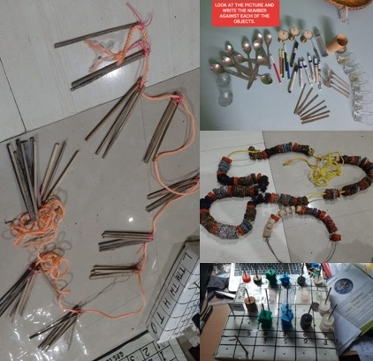

The school is located in remotest corner of North Sikkim and there is no road connectivity but then the teachers are collaborating and participating in the activities which are concerned with teaching and learning by utilizing “best out of waste” materials. Despite the busy schedule of the teachers, they are preparing and facilitating learners for creating joyful and active learning environment in classroom situations. Even many of the materials are purchased by the teachers only and giving this opportunity to poorest of the poor children of Lum village which comprises of Lepcha community. As a part of School Managing Committee (SMC), they also actively participated for helping the school in all aspects. For example, preparing of mid day meal shed (MDM), terracing of field for vegetable garden in school area by giving their free service.



The above extract has been taken from Sikkim Express News Daily Dated 24th May 2020 explains that the concept of earlier history of Sikkim and how money was coined in those days. Therefore, here as a part of learning learners along with the teachers find out the information from different sources as a part of active and joyful learning.

**Reflective Questions**

1. What was my best moment today and how can I have more results like it?
2. What was my most challenging moment and why? How will I respond to it next time?
3. Were my students excited to be in class really? If not, what can I do to change this?
4. How was my mood with others today and how can I improve it?
5. How well did I communicate with others today and how can I do this even better?
6. In what ways did my students surprise me most today?
7. What were the biggest obstacles to improve my practice and how will I overcome them?
8. What did I do today for myself and why is this important?

http:// [www.wabisabilearning.com](http://www.wabisabilearning.com)

**Activity**

1. Lots of waste from broken furniture, doors and window panes are generated in the school. Suggest various items that could be made from such wastes.

**WOODEN WASTES**

**2**

**3**

**4**

**1**

1. How will you make your teaching learning joyful and participatory?

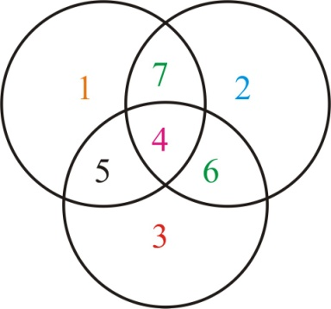

**Note:** As per the availability of the following- food grains, cereals, pulses, stone chips, beads, thread, rotten leaves etc to complete the activity which is meaningful and innovative.

**Let us sum up**

As far as the joyful and active learning is concerned, the activities of different school have been included in the form of youtube and some photographs. The children are actively participated in different activities so that they enjoy and learn something from different way of dealing. Many of the teachers they work hard and satisfy the children with their activities to come out with certain learning outcomes.

In the module, the concept of entertaining the children house wise activities conducted and has the maximum participation and collaboration among the students and they enjoy as well as learning differently. Paper waste has been utilizing in such a manner to have wonderful items from single sheet of paper as a part of joyful and active learning by a group of students guided by the teachers.

According to different classroom situations made by a remotest corner of North Sikkim, mathematics teacher made the classroom inclusive, joyful, meaningful and active participation by the learners to understand the concept of mathematics in a very short span of time. To create such environment in such places is very difficult but it is possible by the attitude of resourceful teachers.

Finally, the points which we have cited above are related to creating joyful and active learning environment in schools are supported by the facts which includes videos, photographs provided by the school authorities and teachers.

**References**

Goodlad, J. (1984), *A place called school*, New York: McGraw Hill.

Puri Amrita, (2014). Ph.D, Army Institute of Education, New Delhi; *How to create joyful learning in the classroom* Nov 4.

Vanita Chopra & Sonal Chabra (2013). Digantar in India: *A case study of joyful learning, Journey of Unschooling and Alternative learning*, Vol VII, Issue 13.

Sikkim Express Daily Newspaper Sikkim, 24th May 2020

Joyfullearningnetwork.com (Retrieved on 22.05.2020)

Gandhi’s Basic education (1939) Retrieved on15.05.2020

(<http://www.kidsdiscover.com>)

**Assessment**

1. Joy captures through
2. Curiosity
3. Crying
4. Weeping
5. All the above
6. Collaboration needs the following
7. A student
8. Teacher and a Student
9. Group of teachers and students
10. None of the above
11. Activities of the children requires
12. Attention
13. Concentration
14. Resources
15. All of the above
16. Meaningful classroom depends on
17. Resourceful teacher
18. Textbook
19. White/Black board
20. Attendance of the students
21. Which of the following historical facts makes the learning joyful?
22. Story of Rajas
23. Story of money
24. Story of culture
25. Story of agriculture

**Additional reading**

1. Edb.gov.hk,

2. Wikimapia.org

3. Amazon.ca

4. IODBookstore.org

Submitted By

1. Mr. Manorath Dahal

Assistant Professor

SCERT Sikkim

E-mail: [mahalangurdahal@gmail.com](mailto:mahalangurdahal@gmail.com)

Ph: 9434384570/8509788747

1. Mr. Suraj Kumar Sharma

Headmaster

Govt. Sec. School Lingi Payong South Sikkim

E-mail: [gautamsuraj1981@gmail.com](mailto:gautamsuraj1981@gmail.com)

Ph: 7551835194/7001121284

**Please note that whatever suggestions has been given to us, we have already gone through and rectified wherever necessary.**